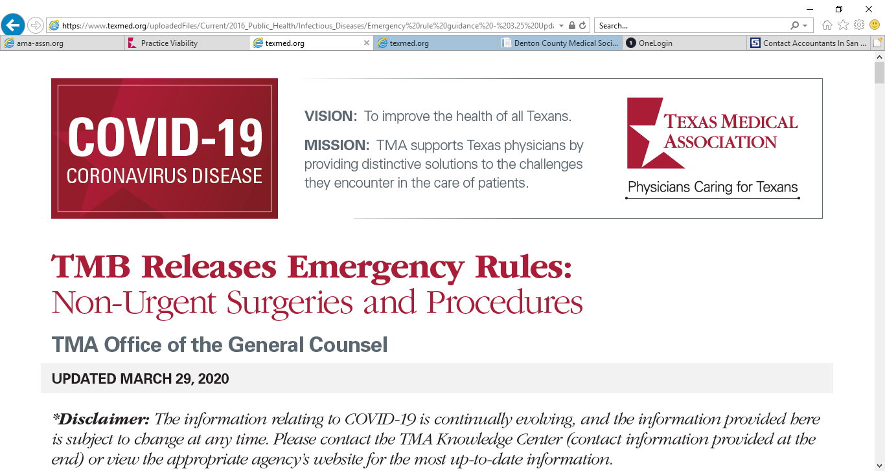

**Certified Public Accountants**

The following list shares information for select Certified Public Accountants (CPAs) in Texas. These CPA firms are known to the Texas Medical Association (TMA) or local county medical societies. However, TMA has not vetted nor endorsed these companies, but we wanted to provide general information for physicians needing to seek the professional advice of a CPA. This list is not exhaustive. Should you choose to contract with them, be sure to execute a business associate agreement before providing access to any protected health information.

**Carr Riggs & Ingram**

<https://www.cricpa.com/>

Texas Locations: Austin, Brownsville, Conroe, Corpus Christi, Dallas, El Paso, Georgetown, Harlingen, Houston, Lubbock, McAllen, The Woodlands

Phone Number: Per location

**Sol, Schwartz & Associates, P.C.**

<https://www.ssacpa.com/>

San Antonio, TX

Phone Number: (210) 384-8000

**Phillips & Associates**

<http://phillipsassociates.emochila.com/>

Lubbock, TX

(806) 791-3904

**Atchley & Associates**

[http://www.atchleycpas.com/](https://urldefense.proofpoint.com/v2/url?u=http-3A__www.atchleycpas.com_&d=DwQGaQ&c=euGZstcaTDllvimEN8b7jXrwqOf-v5A_CdpgnVfiiMM&r=rZZ6mFJWeJSefJYteUPMj2UxjpJW2SiyqCXXj0lpiCU&m=6pkmBupuOSgVTKdofF4hzDVDtjPvgVR3yNj_NOWBwg0&s=7Mtcd1B9YnLu4N-MG5tUdC0IZBxSxulsbLcP3DON1QU&e=)

Austin, TX

Phone: (512) 346-2086

**Salmon, Sims, & Thomas**

<https://www.sstcpa.com>

Dallas, TX

Phone: (972) 739-1268

**Jaynes, Reitmeier, Boyd & Therrell, P.C.**

[www.jrbt.com](https://urldefense.proofpoint.com/v2/url?u=http-3A__www.jrbt.com&d=DwQFaQ&c=euGZstcaTDllvimEN8b7jXrwqOf-v5A_CdpgnVfiiMM&r=rZZ6mFJWeJSefJYteUPMj2UxjpJW2SiyqCXXj0lpiCU&m=h9mecuucTTPkzTqTc0pobGO5zJKERDGeOtYe8lQzP2Y&s=ZisJ7Oelo4mEihSdETTFw3kDV-LixkzpSKq63hp3hA0&e=)

Waco, TX

Phone : (254) 776-4190