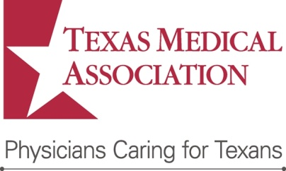

[Date]

The Honorable [Member’s First and Last Name]

[U.S. House of Representatives or U.S. Senate]

[Mailing Address]

[Fax Number or Email Address]

Dear [Representative or Senator] [Member’s Last Name]:

The [your organization] is partnering with the Texas Medical Association (TMA) on a bike helmet giveaway event in District [number] to prevent life-altering or fatal brain injuries. TMA’s Hard Hats for Little Heads program encourages children to be active and allows TMA physician and medical student members, and their spouses to take an active role in prevention and safety by giving away bicycle helmets to children in their communities. We invite you to attend our upcoming [your project].

TMA’s Hard Hats for Little Heads program has been helping prevent head injuries in Texas children since 1994. The program urges use of a properly fitted helmet for all sports on wheels: bicycling, skateboarding, rollerblading, and riding a scooter. **TMA has given nearly 400,000 helmets to Texas children since the program began.**

Our Hard Hats event will be [date and time] at [location]. The helmet giveaway will include [event details, logistics] and last approximately [length of time]. We would be honored if you might agree to [observe, speak, join with us in a photo opp, or whatever role you want him or her to play]. You will have the chance to visit with various community leaders and organizations [list names of key participants]. Should you be able to join us, we welcome the opportunity to work with your press secretary to invite local media to cover the event.

I appreciate your consideration of this request. Your office can reach me at [phone number] or [email address] to follow up.

Sincerely,

[Your name]

[Title]

[Organization]