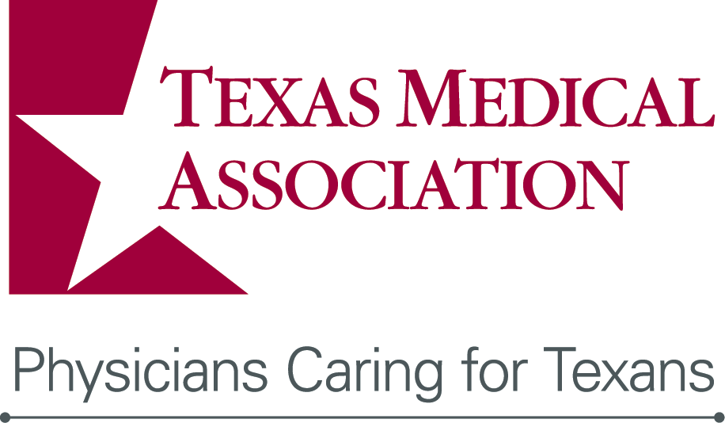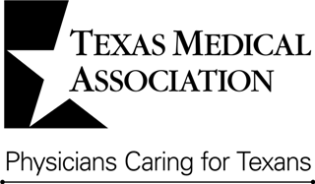

TexMed 2016 Quality Poster Session

Sponsored by TMF Health Quality Institute

|  |
| --- |
| **Checklist for Submitting an Abstract** |
| ___ Review the Instructions, includes timeline  ___ Complete the appropriate abstract form  ___ Complete the Biographical Data and Disclosure Form  ___ E-mail completed forms to posters@texmed.org by Friday, March 25, 2016  ___ Register for the conference  ___ Make hotel reservation |
| **Contact for questions**  E-mail: posters@texmed.org Phone: (512) 370-1423 |

# General Information

**Purpose & Eligibility**

The primary goal of the TexMed 2016 Quality Poster Session, to be held at the Hilton Anatole Hotel Dallas, is to encourage the exchange of applicable best practices among Texas physicians. All Texas physicians, residents, medical students and medical professionals, regardless of practice type or setting of care, are encouraged to submit abstracts using the appropriate abstract from for potential presentation at the conference.

TMA welcomes abstracts not directly related to QI and research projects on quality. This category is referred to as clinical. Each category will be judged separately. Content should enhance knowledge in the field of clinical care and be relevant to a given patient population. Physicians submitting an abstract under the clinical category may be invited for a poster presentation at the discretion of the judges.

New this year is the Enhanced Perioperative Recovery and the Future of Surgical Care program abstract section. Select this section and your poster will be included in the judging onsite by that program judges. This program will include surgical quality and care, perioperative recovery from the viewpoint of a surgeon and an anesthesiologist.

Poster presentations are scheduled for Saturday, April 30, 2016 and will be grouped by content similarity. Posters will be requested of all accepted abstracts with authors asked to be present for individual presentation and Q&A during the hosted presentation from 8:00 to 9:00 A.M. on Saturday, April 30, 2016.

The Abstract, Biographical Data and Disclosure Forms must be received by the TMA by the deadline to be eligible for the TexMed 2016 Quality Poster Session. The top thirty (30) abstracts with the highest scores will be invited to present a poster.

**The deadline for submitting all forms is Friday, March 25, 2016 at Midnight CST.**

**Review Procedure**

TMA’s selected physician judges will evaluate the abstracts using established criteria.

**Travel Voucher & Recognition Awards**

All selected submissions may apply to receive a $100 travel voucher to offset costs associated with attending TexMed 2016. We will confer first, second and third place awards for those submitters who submit the most outstanding QI, research, and clinical projects. Participants will be recognized at TexMed 2016 and will be published on the TMA website.

**Notification of the acceptance status of all submitted abstracts and further instruction (if accepted) will be provided as quickly as possible.**

# Timeline

# Important Dates & Times

|  |  |
| --- | --- |
| October 1, 2015 | TexMed 2016 Quality Poster Session forms are available online. |
| March 25, 2016, Midnight | Deadline. Final submission date for applicants. |
| March 2016 | Accepted abstracts are provided with further information. |
| April 4, 2016 | Final applicants are notified on submissions. |
| April 30, 2016  7 to 7:50 am | Poster setup for TexMed 2016 Quality Poster Session and continuing medical education (CME) session. |
| April 30, 2016  7:50 to 8:00 am | Awards ceremony for first, second, and third place winners. |
| April 30, 2016  8 to 9:00 am | Hosted Poster Session. Selected submissions will be expected to host their posters for one-on-one presentation and Q&A (or have a member of the team do so). |
| April 30, 2016  9 am to 1:30 pm | Posters In Exhibit Hall. Posters will be on display to TexMed 2016 conference attendees. |
| April 30, 2016  1:30 to 2 pm | Poster Breakdown. Poster exhibitors will be expected to pack their posters. TMA cannot guarantee safety or condition of posters after this time. |