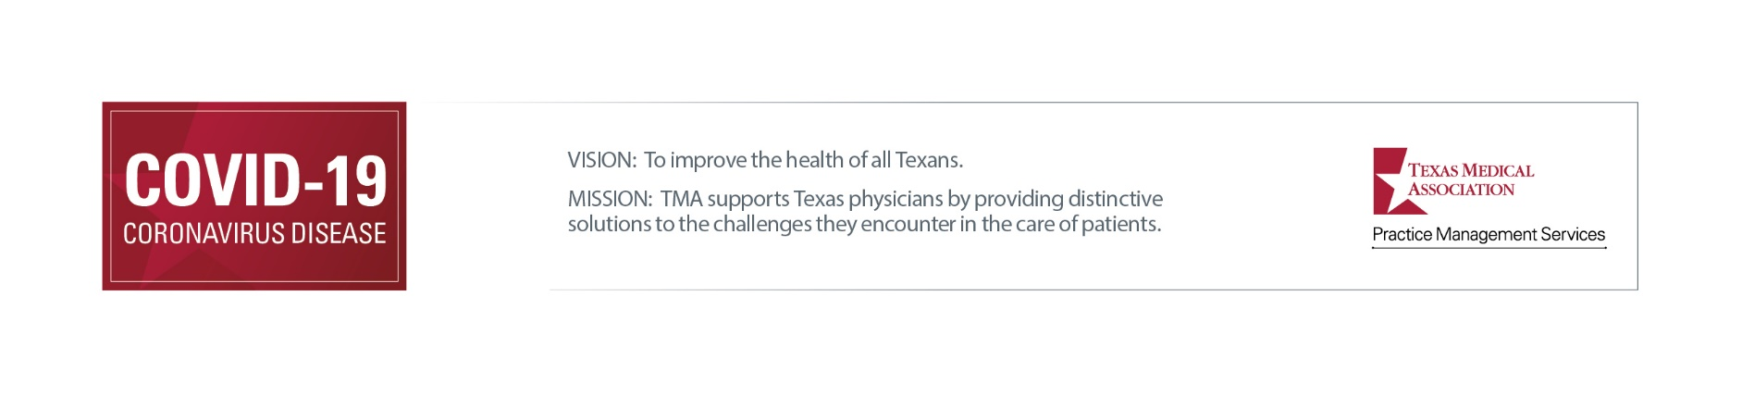

Editable Electronic Flyer for Your Practice

TMA designed this editable, printable flyer to educate the public about specific steps your office is taking to help reduce the transmission of COVID-19. Before printing or displaying the flyer, offices must edit details in the file including all items highlighted in grey and remove any measures the office is not taking, as well as review all remaining safety precautions to ensure the office is implementing them as written.

Please note this does not replace the notice required by the Texas Medical Board (TMB) in certain medical settings. (22 TAC §190.8(2)(U)). A violation of this rule may be considered unprofessional conduct. For more on TMB’s emergency rule, please review TMA’s white paper and FAQ on TMB’s rule, which include references to a sample notice provided by TMB and an alternative notice created by TMA.

NOTICE: Texas Medical Association provides this form with the express understanding that 1) no attorney-client relationship exists, 2) neither TMA nor its attorneys are engaged in providing legal advice, 3) the information is of a general character, and 4) this communication is not confidential and/or privileged. This is not a substitute for the advice of an attorney. Any legal forms are only provided for the use of physicians in consultation with their attorneys. TMA assumes no legal responsibility for loss or damages resulting from the use of this information. You should not rely on this information when dealing with personal legal matters; rather, you should seek legal advice from retained legal counsel. Certain links provided with this information connect to websites maintained by third parties. TMA has no control over these websites or the information, goods, or services provided by third parties. TMA shall have no liability for any use or reliance by a user on these third-party websites.

STOP! Before entering this office,
please call phone number.

P Face coverings are required. Forgot yours this time? Ask if we have an extra one.
P “Well” and “sick” patients are separated, whenever possible.
P Scheduled “well” visits are in the [morning], “sick” visits in the [afternoon].
P Exam rooms, waiting rooms, and/or entrances are designated “well” and “sick.”
P Temperature checks are conducted [at patient vehicles / before office entry].
P Patients are asked to wait [in their vehicle / outside the facility] until contacted for
office entry.
P Social distancing is required throughout the office.
P Unless necessary for the appointment, companions are asked to wait outside.
P Office and exam rooms are thoroughly cleaned.
P Hand sanitizer or areas for handwashing are available.
P [Alternative appointment types / Telemedicine services] are offered, when appropriate.

