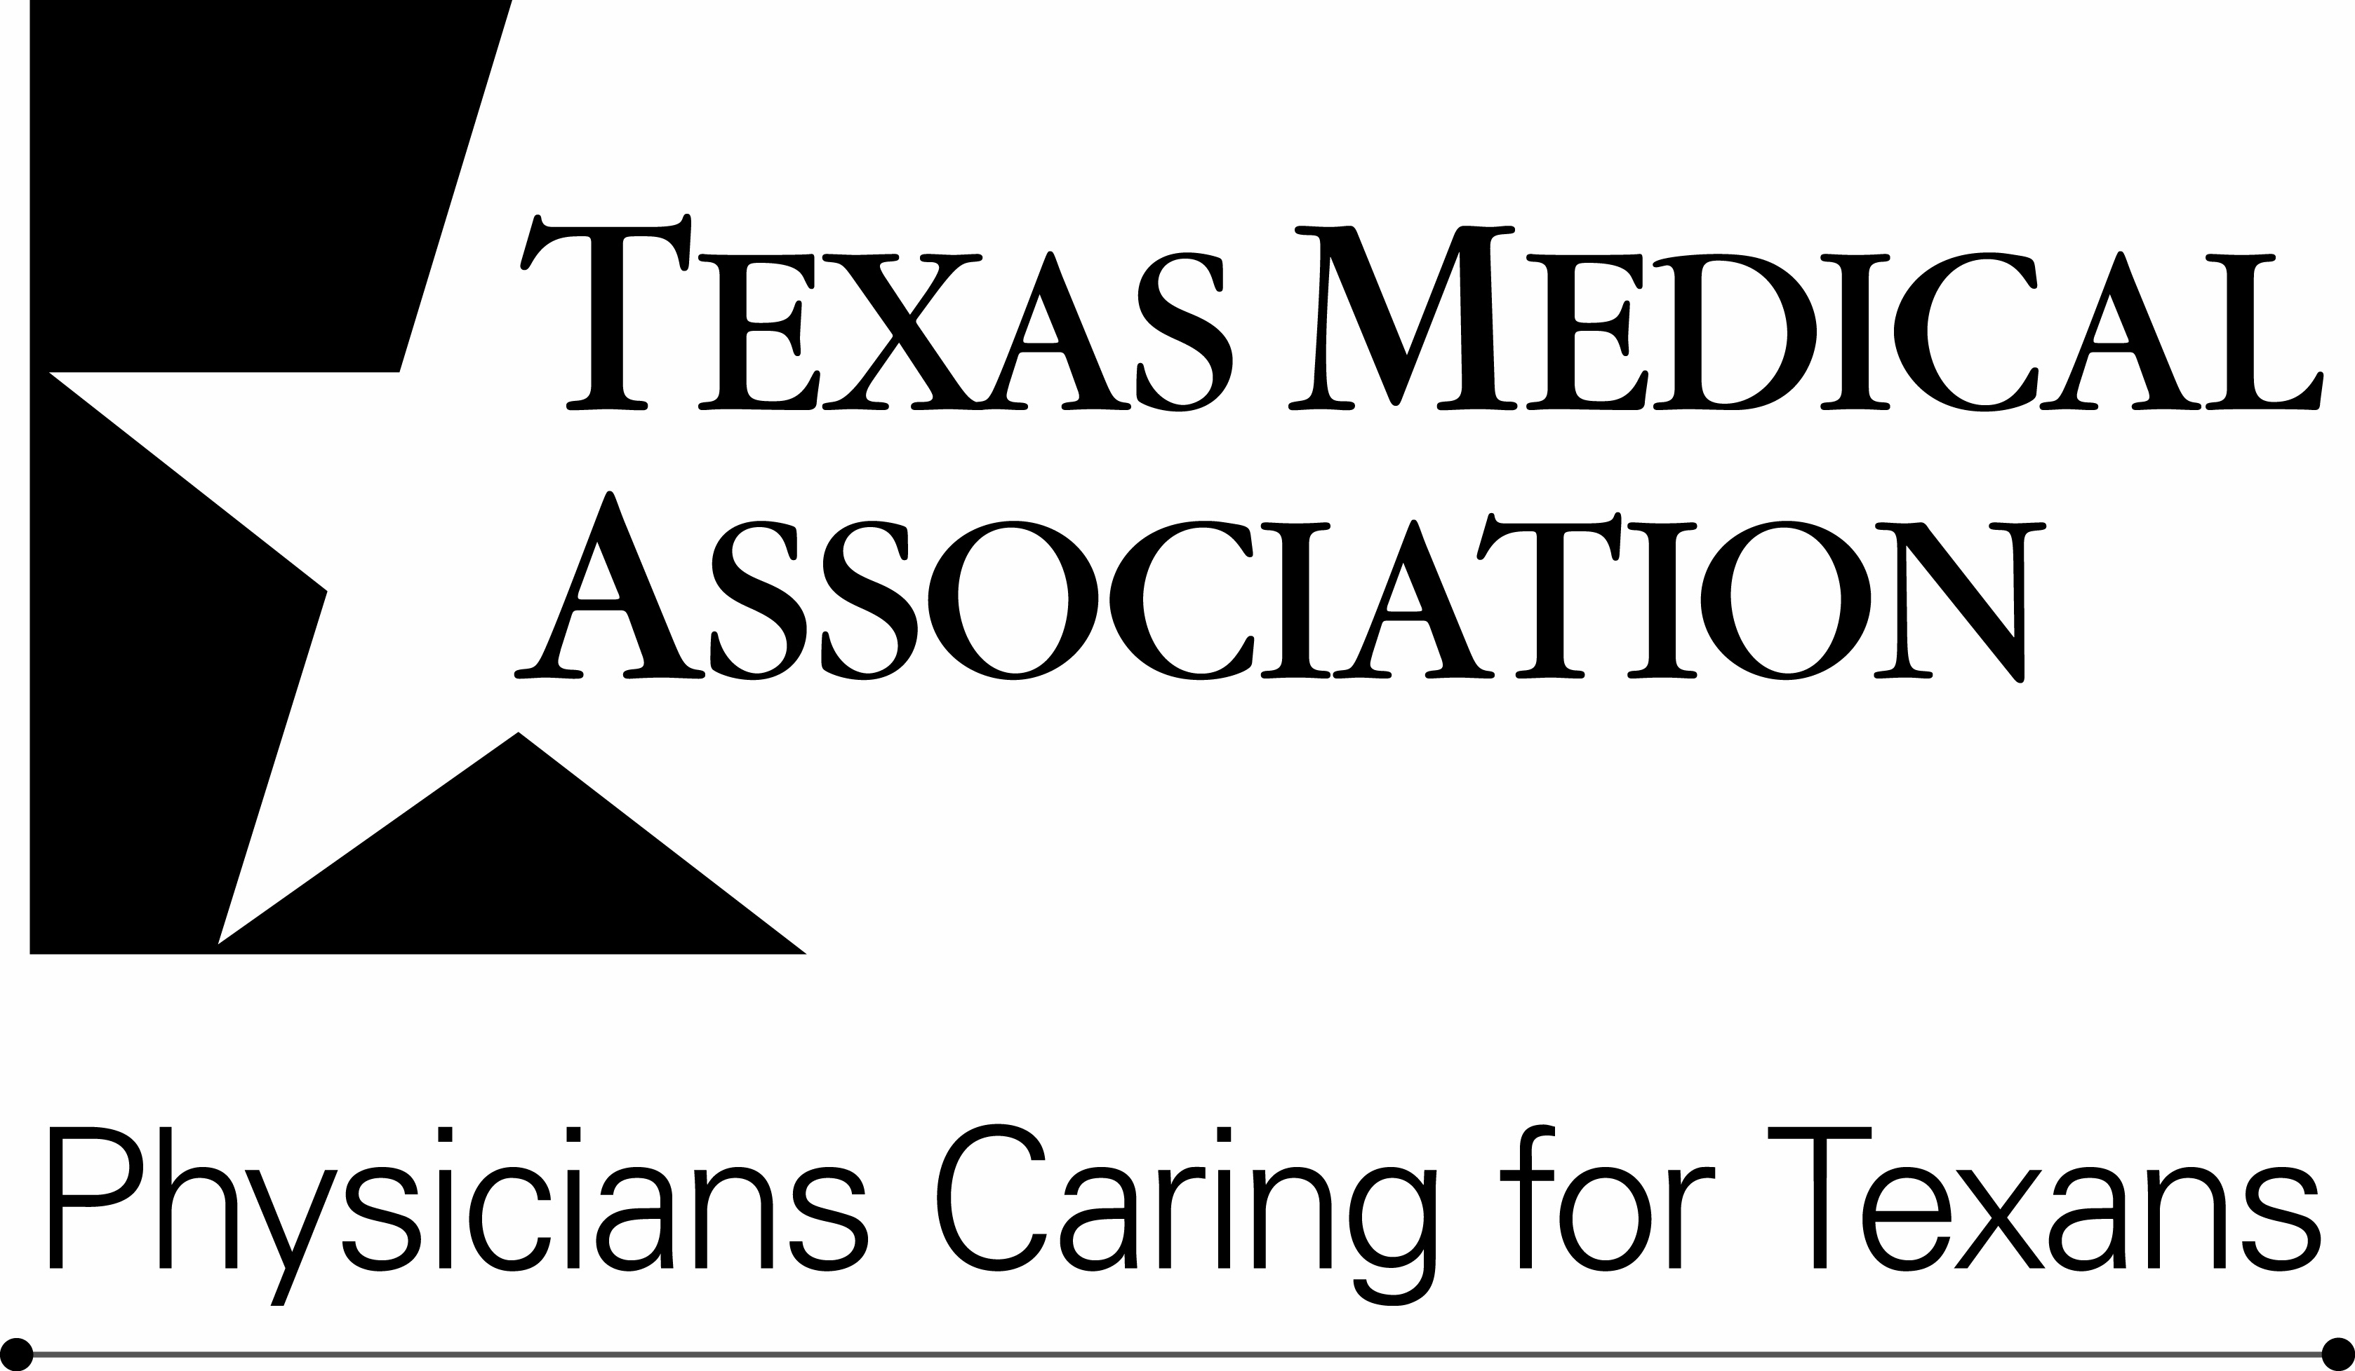

Medical Student Section

Chapter of the Year Award

Nomination Form

This award is given annually to the Chapter of Texas Medical Association that exemplifies leadership, dedication, and service to the Texas Medical Association, the American Medical Association, their respective Medical Student Section, and all Texans.

Nominations will be accepted from TMA Medical Student Section (TMA-MSS) members only, through January 20. The TMA-MSS Executive Council will consider all nominees, select the award recipient at Winter Conference, and the award will be given during the TMA-MSS Business Meeting at TexMed.

To nominate a chapter, please provide the following information:

Chapter: ____________________________________________________________________________

Address: ____________________________________________________________________________

City, State & Zip: _____________________________________________________________________

Phone number: _____________________________ Email: ___________________________________

Please explain in 200 words or less why the nominee should receive the Chapter of the Year Award. You may use the space below or submit a separate sheet.

Nomination submitted by (please print): ____________________________________________

Your email address: ____________________________________________________________

Fax completed forms to (512) 370-1693 or email to MSS Coordinator MSSinfo@texmed.org.

Nomination forms must be received no later than January 20 to be considered.

